Url :- https://l2pjrdddn4clo.mocha.app/

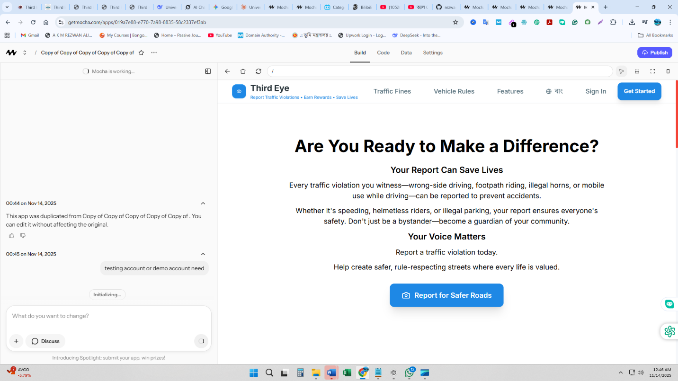

I'll create demo accounts for testing the app. Let me set up a test citizen account with all verifications completed so you can explore all features.
Demo accounts have been created and documented! You can now test the app with these credentials:
Citizen Account (recommended for testing):
- Mobile: 01700000001
- Password: TestPass@123
Officer Account:
- Mobile: 01700000002
- Password: Officer@123
Both accounts have completed verification and the citizen account already has 3 sample cases (2 approved, 1 pending) with ৳2,400 in earnings.
Check the DEMO_ACCOUNTS.md file for complete testing scenarios and details.

